**BMI is calculated for all the users in the table.**

To do this there are 2 columns added to the table Height and BMI.

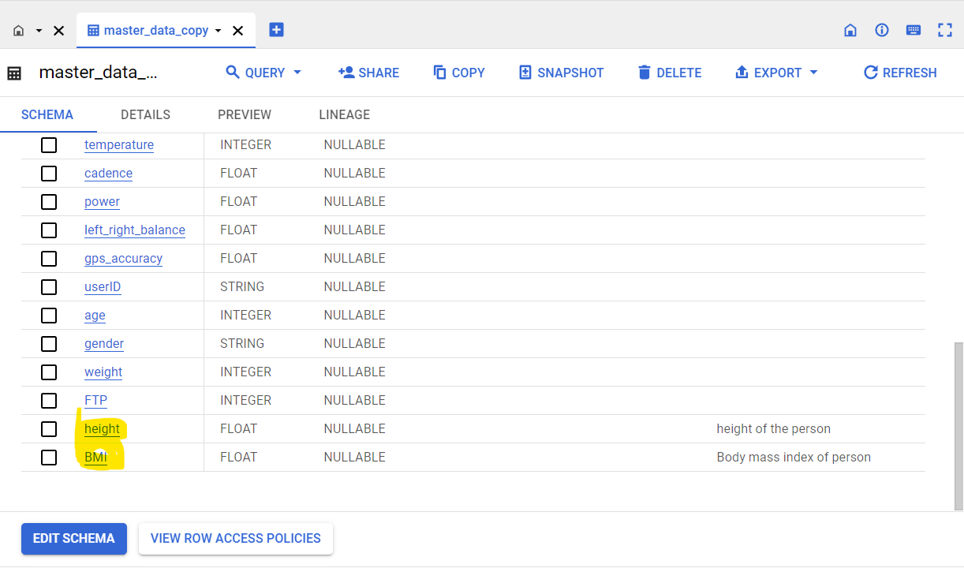

Height Column is updated with few random values for different users using below query:

update `sit-23t1-fit-data-pipe-ee8896e.fitness_data.master_data_copy`

SET height = 165

where USERID= 'U1000006'

Now BMI value is calculated as follows:

update `sit-23t1-fit-data-pipe-ee8896e.fitness_data.master_data_copy`

SET BMI = weight*10000/(height*height)

where userid IN (SELECT distinct USERID from `sit-23t1-fit-data-pipe-ee8896e.fitness_data.master_data_copy`)

6. Queries are created to fetch out views for Monthly and Yearly BMI:

**BMI_MONTHLY_REPORT: (BMI of all users for previous month is generated)**

select userid,

avg(weight)AS weight,avg(height)as height,avg(BMI)as BMI,

case

when avg(BMI) < 18.5 then "Under weight"

when avg(BMI) >=18.5 and avg(BMI) < 25 then "Normal"

when avg(BMI) >=25 then "Obese"

end as Coach,

EXTRACT(month from date_AEST) AS MONTH,

EXTRACT(YEAR from date_AEST) AS YEAR

from

`sit-23t1-fit-data-pipe-ee8896e.fitness_data.master_data_copy`

where EXTRACT (YEAR from DATE_AEST) = EXTRACT (YEAR from CURRENT_DATE) and

EXTRACT (MONTH from DATE_AEST) = EXTRACT (MONTH from CURRENT_DATE)-1

group by userid,month,year

**BMI_YEARLY_REPORT: (BMI of users for all months in the year so far is generated)**

select userid,

avg(weight)AS weight,avg(height)as height,avg(BMI)as BMI,

case

when avg(BMI) < 18.5 then "Under weight"

when avg(BMI) >=18.5 and avg(BMI) < 25 then "Normal"

when avg(BMI) >=25 then "Obese"

end as Coach,

EXTRACT(month from date_AEST) AS MONTH

from

`sit-23t1-fit-data-pipe-ee8896e.fitness_data.master_data_copy`

where EXTRACT (YEAR from DATE_AEST) = EXTRACT (YEAR from CURRENT_DATE) and

EXTRACT (MONTH from DATE_AEST) <= EXTRACT (MONTH from CURRENT_DATE)

group by userid,month

7. Views are created using the above queries:

8.Visual Representation of BMI is Developed:

**BMI_YEARLY_REPORT:**

1. Click on BMI_YEARLY_REPORT view in the big query explorer and View opens in the right pane as below:

1. Click on drop down next to export label in the right pane and there will be option explore with sheets as below:

1. Click on Explore with sheets and new sheets opens with preview data from view result. Name that sheet to BMI_YEARLY_REPORT:

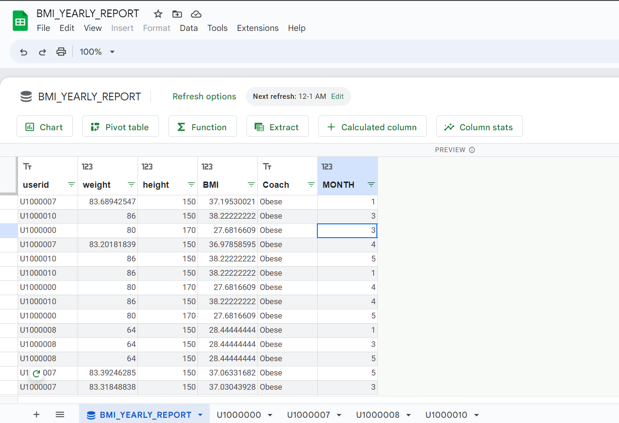

1. Now click on Chart Label to create charts and new sheet opens next to it:

1. Above Report is created by selecting userid in x-axis and BMI in series and sorted by MONTH and filtered by userid columns.
2. Select one user id from filter to fetch BMI of user for all months in the year.
3. Explore the customize options to style the dashboard.
4. Sheets for different users are created as below by selecting each user in each sheet:

1. In the first sheet where data preview is present click on Schedule Refresh option on top to schedule the refresh of reports:

1. All the sheets in the report can be scheduled for refresh:

1. Reports can be published to audience by clicking on share on top right and giving access to Deakin group only in view of security:

1. Now this report can be accessed using URL: <https://docs.google.com/spreadsheets/d/1xOI-TcMc_0_mIxODiJQKkvOOvC21zWWOXIEvgsvVZUo/edit?usp=sharing>

**BMI_MONTHLY_REPORT:**

BMI_MONTHLY_REPORT is also visualised using the above steps. But here data of all users for previous month is shown.so only one chart is created with userid in x-axis and BMI in series and sort by user id:

This report can be accessed using:

<https://docs.google.com/spreadsheets/d/1Cg5NDlH2vKCdIj6nt2cYlkssPWfPipauB3Zjih1osLA/edit?usp=sharing>